FRAMEWORK AGREEMENT CESAR 2.0
Framework agreement regarding usage of the SSNF package of agreement when hire of Dark fibre and other services that can be provided by sellers of Swedish Local Fibre Alliance

This framework agreement (”Framework Agreement”) was concluded between
- Svenska Stadsnätsföreningen Service AB , Reg.nr. 556676-6076,
Holländargatan, 111 60 Stockholm.”[SSNf]”), and
(2) [Operator], [reg.nr], [address], (”Buyer”)._____________________________
[SSNf] and the Buyer are individually called ”Part” and joint ”Parties”.

Background
Swedish Local Fibre Alliance has in cooperation with operators on the market, developed a package agreement which handles the contractual relationship between the Swedish city network/sellers and buyers/operators. Package of agreement regards services which can be delivered today, e.g. black fibre and capacity. Other services will be available for delivery in the future and described in service specification documents/annexes to the Package of Agreement.

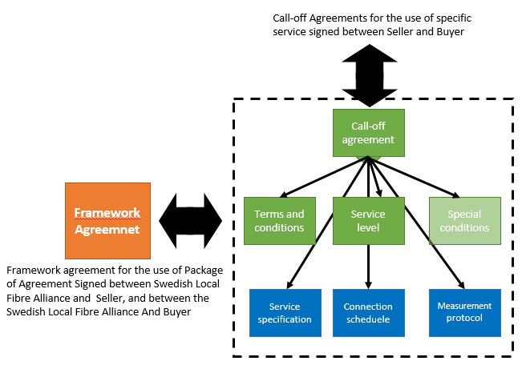

1. Construction Package of Agreement

1.1
The package of agreement is constructed as follows and if possible contradictions in the policy document has priority in the following order
- Supply Agreement for specific called-off service
- Special conditions (if existing)
- General conditions for leased connections
- Service levels
- Service specification

In the case of discrepancies, the Swedish version of this agreement takes precedence over the English version.

In each Supply Agreement signed by Seller and Buyer, it shall be made clear which other documents in the Package of Agreement that refer to the call-off. General conditions, Service levels and Service specification shall always be included.

2. Responsibility of the Parties

2.1
Buyer should, from the signature of this Framework Agreement, use the Package of Agreements at work offers and the signing of new services.

2.2
The Buyer undertakes to comply to the content of the Package of agreement when the Supply agreement has been signed. Possible deviations from the Package of agreement shall be explicitly specified in Special conditions related to a specific call-off.

3. Progression and revision of Package of agreements

3.1
The content of the Package of agreement must progress and be revised in line with market and service offer changes. All changes imposed in Package of agreement shall before the suggested imposition, be approved by a joint working group for the agreement chosen by the two parties. The parties undertakes to follow and practice those approved changes for call-offs in the future.

3.2
There shall be a joint working group for the agreement that consists of members as follows
- persons appointed by Swedish Local Fibre Alliance, one of whom shall be appointed chairman, who have (4) four votes all together, regardless number of participants from the city networks.

- persons appointed by the Operators who have signed a contract with SSNF, who have a total of three (3) votes, regardless number of participants from operators.

Decisions of changes in the Package of agreement requires 6/7 parts majority within the joint working group for the agreement.

3.3
The joint working group shall meet at least twice a year and the chairman is responsible for distributing the notice, agenda proposals and to see to that protocol is kept.

The joint working group may nominate a working committee whose obligation is to continuously follow up the cooperation between the Parties, according to the Agreement. The working committee is, if needed, the receiver of amendments regarding the content and form of the Agreement. It shall also suggest possible alterations to the joint working group.

4. Charges

There will be no compensation for use of Package of agreement. The parties stand for all own costs related to the work of the joint working group.

5. Business system
Parallel to the Package of agreement, SSNf and a number of Operators have developed a business system handling contractual relations, service deliveries and quota process plus service orders at the Swedish city network. The system is called CESAR2. The business system shall be based on the documents included to the Package of agreements. How and in what form the business system may be used, the construction, compensations etc. are not included in this Framework agreement.

6. Confidentiality

6.1
The Parties undertake not to reveal the content of the Framework agreement or other information one Part receives from the other Part within the framework of the Parties cooperation, either technical, commercial or of other sort and regardless of documentation or expressly stated with confidentiality (”confidential information”), without signed agreement from the other Part. The Parties undertake to take required actions to prevent such Confidential Information to be revealed to outsiders or others the Party can control in this respect.

6.2
The Parties are entitled to reveal the occurrence of this framework agreement and such information which are requisite to utilize the Parties’ rights or implementation of obligations under the Framework agreement.

6.3
Since both or one Party may come to be subject to the rules of publicity and confidentiality, both Parties have agreed that by possible request of disclosure of general documents, the Party of whom such requirement is asked, should with high priority notify the other Party, in writing, of every such request, emerged within the framework of the Parties’ cooperation in questions regarding this Framework agreement. The Party of whom the request is aimed shall consult the other Party and consider the viewpoints. The Party of whom the request is aimed is however only obliged to provide the other Party the possibility to consultation during one (1) workday, due to an urgency requirement at the confidentiality assessment

6.4
Disclosure of Confidential information by a Party, in accordance to the law, court or other authority, shall not be considered an offence to the obligations of confidentiality.

6.5
Regardless the reason for termination of the Framework agreement, the obligations of confidentiality shall be applied during the validity period and of a period of five (5) years later.

7. Transfer

In accordance to this Framework agreement, the Parties are not entitled to totally or partly transfer their rights and duties without a written consent from the other Party. The consent shall not be denied without reasonable grounds. However, the Party is always entitled to transfer the Framework agreement to another company within the same concern as the Party. A company within the same concern should be understood as referring; (1) Parties’ parent concern, 2) companies owned by Party, or 3) companies owned by Party’s parent concern, given the shareholding reaches at least 50%. If such company fail to comply with their obligations, the original Party is responsible that obligations are fulfilled.

8. Duration of agreement and early termination etc.

8.1 Duration of agreement and expiration time
The Framework agreement is valid during an initial duration of agreement of two years. If the parties have not agreed otherwise, the Framework agreement expires with tacit renewal of one-year periods, if not cancelled one month before respective termination of the duration of agreement at the latest.

8.2 Validity
The Framework agreement is valid during the whole duration of agreement with a remnant effect for agreements made during the time period. Supply agreements made during the duration of agreement are also valid with remnant effect at early termination according to point
8.3 Early termination
Party is entitled to cancel the Framework agreement before its termination date, with immediate effect

- at a material breach of contract, if the other Party has been informed of the breach of contract in writing and has not competed the remedy within 30 days from notification, or

- if the other Party could reasonably apprehend insolvent

c) if the other Party has made repeated material breach of contract, but has corrected such faults in accordance to point 8.3 a) above.

9. Dispute

This contract shall apply to the Swedish law. If disagreements between the Parties, a dispute of interpretation or implementation of this Framework agreement can be judged by implementation of the Swedish law and by the rules of Arbitration institute of the Stockholm chamber of commerce.

Stockholm 2015-
Place and Date

___________________________ _____________________

Mikael Ek, VD Authorised signatory
Svenska Stadsnätsföreningen Service AB Company name
556676-6076 Reg.no

